Assignment 12 – RIP
Student Name | Shreya Panchal
Theory Topic | RIP concepts: Hop count, updates, and convergence.
Practical Topic | Configure RIP on a multi-router network.
Task | Capture RIP updates using simulation tools and analyze them.

Task 1: Three-Router Topology Interface Setup
Objective: Set up a network topology with three routers in Cisco Packet Tracer, connect them using serial or Ethernet links, and assign IP addresses to all interfaces.
Answer/Configuration Steps:
- Three routers (Router0, Router1, Router2) were added to the workspace.
- The routers were connected in a chain setup using Serial cables (Serial 0/3/0).
Router0 Interface Configuration:
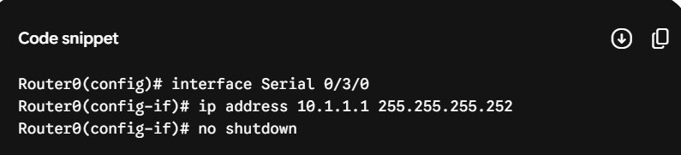
Router1 Interface Configuration:
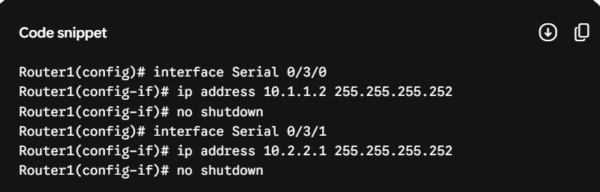
Router2 Interface Configuration:
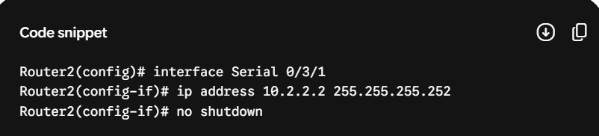

Task 2: Enable RIP Version 2 and Network Advertisement
Objective: Enable RIP version 2 on all three routers in your topology, advertise all directly connected networks, and verify that each router learns routes to all subnets using the show ip route command.
Answer/Configuration Commands:
Router0 Configuration:
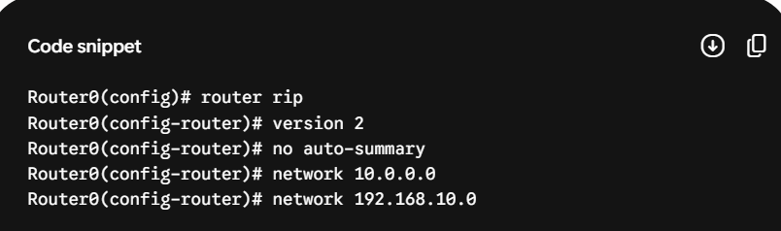
Router1 Configuration:
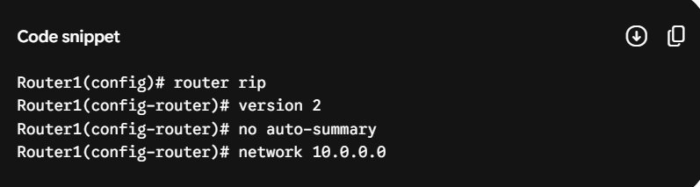
Router2 Configuration:
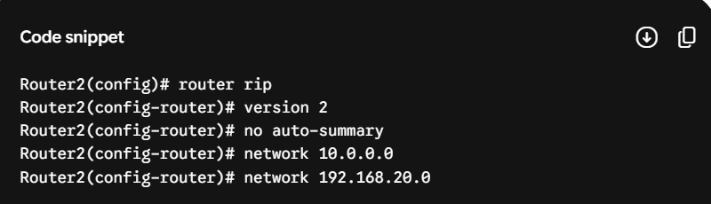
Verification: Running show ip route on Router0 confirms it learned Router2's remote network via RIP (indicated by R):
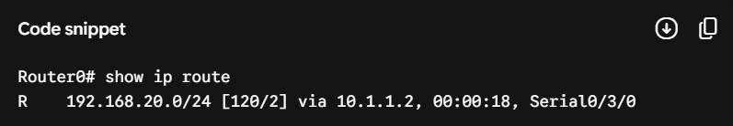

Task 3: Modifying Hop Count Metric
Objective: Change the hop count metric for one of the networks by adding an extra router between two existing routers, then observe and record how the hop count value changes in the routing tables.
Answer/Observation:
Before Change: Router0 was reaching Router2's LAN via 2 hops ([120/2]).
Modification: A fourth router (Router_New) was inserted between Router1 and Router2, creating an extra link. RIP paths were updated automatically.
After Change Observation: Running show ip route on Router0 showed the metric value for reaching Router2's remote LAN increased automatically from 2 hops to 3 hops:
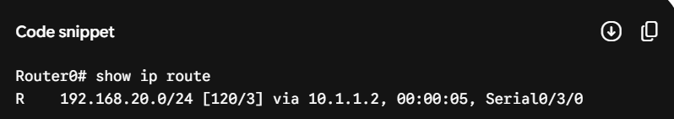
This proves that RIP relies directly on hop counts to measure path distance.

Task 4: Packet Capture and Analysis of RIP Updates
Objective: Use the simulation mode in Cisco Packet Tracer to capture and analyze RIP update packets as they are exchanged between routers. Filter for RIP packets in the simulation panel and note the source, destination, and advertised routes in each update.
Answer/Analysis Report:
Simulation Steps: Switched Packet Tracer to Simulation Mode and selected RIP in the event list filters.
Captured Packet Breakdown:
Protocol Type: RIPv2
Source IP: 10.1.1.2 (Interface IP of the neighboring router sending the update)
Destination IP: 224.0.0.9 (The standardized multicast address utilized by RIPv2 to distribute updates to nearby routers)
Advertised Routing Payloads: Inside the routing update payload, the packet contained information regarding subnets like 192.168.20.0/24 along with its metric value (hop count = 1). This allows the receiving router to add the route to its table.

